Finding the Autocorrelation Function Given a Transfer Function

Discrete-Time System

The following assumes a zero mean white noise process with unity variance driving a linear time-invariant system. Starting with a partial fraction expansion of the transfer function H(z) where M<=N and assuming no repeated modes,

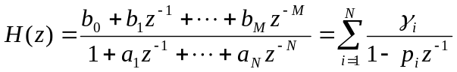 . (1)

The Power Spectrum can be expanded as [Papoulis, pg. 410},

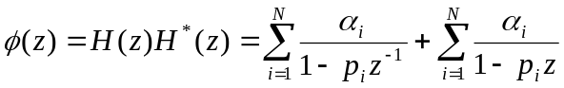, (2)

where

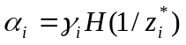. (3)

Then the autocorrelation function is

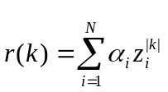 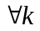. (4)

Continuous-Time System

The following assumes a zero mean white noise process with unity variance driving a linear time-invariant system. Starting with a partial fraction expansion of the transfer function H(s) where M<=N and assuming no repeated modes,

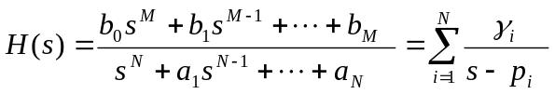 . (5)

The Power Spectrum can be expanded as,

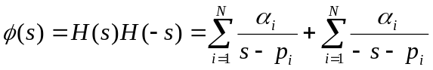, (6)

where

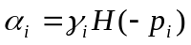. (7)

Then the autocorrelation function is

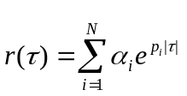 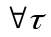. (8)

